PRIMARY FONT
Helvetica Neue
Weight – Regular

SECONDARY FONT
Helvetica, Arial, Sans-Serif

BODY FONT COLOR
Color: #666666

FONT SIZE
Bootstrap 4 Default: 1rem / 16px

ICONS
Font Library: Font Awesome 4

LINE HEIGHT
1.5 rem

LINK COLORS
Link Color (Link Default, Visited, Hover, Active: #17335B
Text Decoration: Underline

PRIMARY BUTTON
Button Background Color: #00B2A5
Button Font Color: #FFFFFF
Button Font Size: 1rem / 16px

Button Background Color: #545454
Button Font Color: #FFFFFF
Button Font Size: 1rem / 16px
SECONDARY APPLICATION BUTTON
Button Background Color: #EFEFEF
Button Font Color: #696969
Button Font Size: 0.8rem / 12px

COLOR CODES

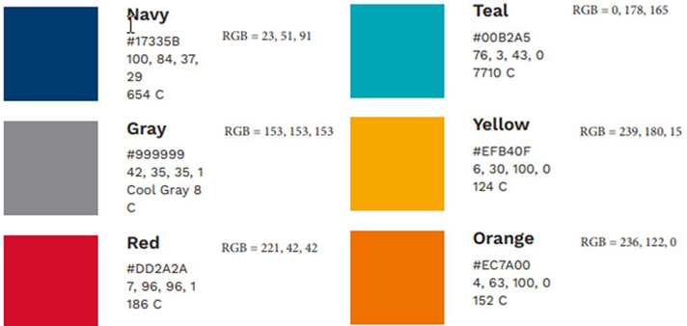

BOOTSTRAP 4.5 DEFAULT STYLES
Bootstrap Standard Gutter Width: 30px (15px left / 15px right)

ICONS
Font Library: Font Awesome 4
Header Icon Color: #737373

TOP NAVIGATION
Icon Color: #737373
Header Navigation Icon Size: 20px x 20px (Dense / Filled)
Mail Icon Alert: #DD2A2A (Red Indicator)

SIDE NAVIGATION (LEFT)
Blue Bar: Color: #17335B
Blue Bar Hover: Color: #0B2241
Blue Bar Selected Background: #0B2241
Blue Bar Highlight Color: # EC7A00

Grey Popout Background: # F5F5F5
Grey Popout Background Hover: # F0F0F0
Grey Popout Background Selected # F0F0F0
Grey Popout Child Menu Hover # C7C5C5
Grey Popout Child Selected: # C7C5C5
Grey Popout Child Menu Selected Text Color: # FFFFFF

Button Height: 50px
Font Size: 1rem / 16px
Icon Color: #FFFFFF
Left Navigation Icon Size: 24px x 24px

ACCORDION SECTIONS
Accordion Header Color: #E3E2E2
Accordion Header Title Font Size: 1rem / 16px

BADGE / CARDS
Badge Header Accounts Color: # 23b2a5
Badge Header Secondary Sections Color: # f6c69f
Top Header Font Size: 1.5rem / 24px
Lower Body Font Size: 0.8rem / 12px
Top Header Icon Size: 20px x 20px

SUPER SEARCH WIDGET
Super Search Icon Color: #545454
Super Search Icon Font Size: 16px x 16px

GRID CONTROLS
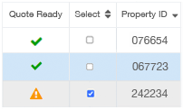
Grid Control Border Color: #e0e3e7
Column Header Labels Font Color: #595959
Column Header Labels Font Size: 0.8rem / 12px
Column Data Font Color: #666666
Column Data Font Size: 0.875rem / 14px
Column Stripe Background Color: # f7f7f7
Column Stripe Hover Color: #ececec
Column Stripe Selected Color: #cfe6f7
Main Button Color: #737373
Main Button Font Size: 0.8rem / 12px

GRID CONTROL ICONS
GC Icon Size: 16px x 16px
GC Icon Color #17335B
GC Icon Disabled Color #a1a6ab

GC Icon Warning Color: #EFB40F
GC Icon Success Color: #119607
GC Icon Include Color: #17335B
GC Icon Filter Color: #545454

ICON DEFINITIONS
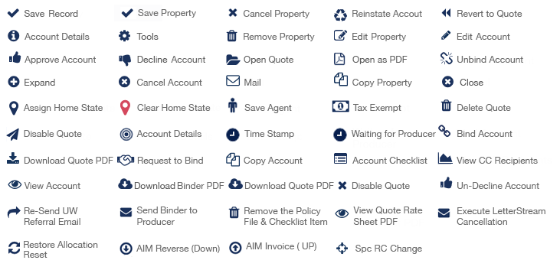

GLOBAL GRID CONTROL STYLES – HOVER/SELECTED

Grid Control Row Hover Color: #ECECEC (Grey)
Grid Control Row Hover Selected: #CFE6F7 (Blue)

GC Pagination Font Color: #17335B

ACCOUNT SUMMARY BADGES / CARDS
Badge Header Properties Color: #00B2A5
Badge Header Quotes Color: #EC7A00

KENDO WIZARD STEP CONTROL
Step Control Background Color: #EC7A00
Step Control Font Size: 1rem / 16px

WIZARD FOREWARD/BACKWARD ICONS

Arrow Icon W/H: 36px x 36px (Custom CSS Buttons)
Arrow Icon Background Color: #CACACA
Arrow Icon Font Color: #FFFFFF
Arrow Icon Font Size: 1rem / 16px

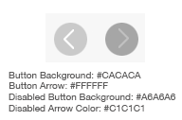

WIZARD SPECIAL ICONS
Information Icon W/H: 16px x 16px
Information Icon Background Color: # A4A4A4
Required Font Color: #DD2A2A
Required Font Size: 0.875rem / 14px

WIZARD PROPERTY DISPLAY BADGE
Badge Background Color: # A4A4A4
Badge Font Color: #FFFFFF
Badge Font Size: 1.875rem / 30px

LEGEND DATA DISPLAY

Legend Title Font Size: 1.125rem /18px
Legend Label Font Color: #737373
Label Background Color: # F5F5F5
Legend Data Label Font Color: # F5F5F5

Label Data Background Color: #FFFFFF
Label Font Size: 0.875rem / 14px

BOOTSTRAP POPUP MESSAGES DEFAULT

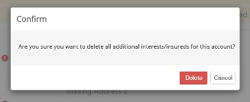

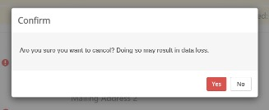

Modal Backdrop Color: # 666666
Modal Title Font Color: # 686868
Modal Header Font Size: h4 – 1.5rem / 20px
Modal Font Weight: 300
Modal Body Background Color: #f6f6f6
Modal Body Text Color: # 565656 (This Bootstrap override should be set in the <p> block level element)
Modal Body Font Size: 1rem / 16px

BOOTSTRAP POPUP MESSAGES WARNING

Modal Header Text Color: # DD2A2A

ACCORDION COLLAPSED STYLES

Accordion Header Background Color: #E3E2E2
Accordion Header Title Font Size: 1.125 rem / 18px
Accordion Border-Bottom Color: #CCCCCC
Accordion Border-Radius: 2px 2px 0px 0px

Accordion Badge Background Color: # 25B2A5
Accordion Badge Font Color: # FFFFFF
Accordion Badge Font Size: 0.75rem / 12px

TOAST MESSAGE DETAILS
Legend Title Font Size: 1 rem / 16px
Legend Label Font Color: #FFFFFF
Label Background Color/Success: #51A351
Label Background Color/Info: #00B2A5
Label Background Color/Error: #DD2A2A
Label Background Color/Warning: #EFB40F

Toast Message Display Position: Top Center / ( Add ‘margin-top: 20px / 1.25rem )
Toast Message Box Shadow:
-webkit-box-shadow: 0px 2px 16px 0px rgba(115, 124, 124, 0.8);
-moz-box-shadow: 0px 2px 16px 0px rgba(115, 124, 124, 0.8);
box-shadow: 0px 2px 16px 0px rgba(115, 124, 124, 0.8);

Toast Message Rounded Corners: border-radius:3px
Toast Message Icon: fa-lg / 1.33rem / 21.28px

RISCALC ALERT MESSAGE DETAILS

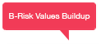
Alert Backdrop Color: # F23B57
Alert Body Font Color: # FFF
Alert Body Font Size: 0.625rem / 10px
Alert Font Weight: 300

RISCALC TAB MENU DETAILS

Tab Menu Font Size: 14px
Tab Menu Enabled Background Color: FFF
Tab Menu Enabled Font Color: # 666666
Tab Menu Tab Background Color: #E2E2E2
Tab Menu Disabled Button Color: # F0F0F0
Tab Menu Disabled Font Color: # BFBEBE

AMRISC ACCOUNT ALLOCATION GRID

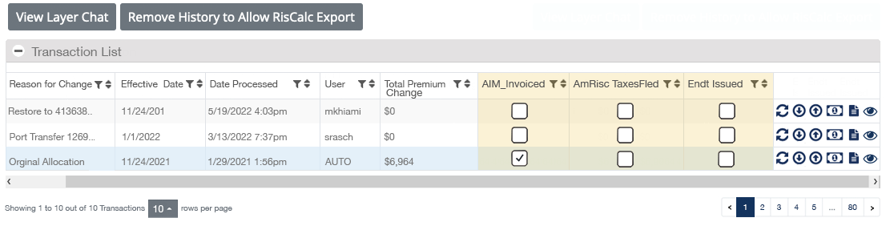

Grid Control Column Highlight BG Color: # FBF2D6

